|  |  |
| --- | --- |
| **Rectangular Arrays & Area** | |
| **Enrichment Investigation #1** | |
| Common Core State Standard(s):  3.MD.5  3. MD.6  3. MD.7  3. MD.8 | Standard(s) for Mathematical Practice:  1.Make sense of problems and persevere in solving them  2.Reason abstractly and quantitatively  3. Construct viable arguments and critique the reasoning of others  4. Model with mathematics  5. Use appropriate tools strategically  6. Attend to precision  7. Look for and make use of structure |
| Materials Needed:   * Blackline Masters:   + Planning a Flower Garden   + Flower Budget Sheet   + Facts & Prices of Common NC Flowers * Rulers and/or yardsticks * Colored Pencils * Graph Paper * Pencils * Calculators * Computer * Optional: plant catalogs and garden center circulars | |
| Instructions:  *This investigation encourages students to think like landscape architects. Students will first choose either a square or a rectangle for the shape of their flower garden. They will then need to design a flower garden including the area and perimeter, select plants and calculate the total cost while staying within a $100 budget. After choosing specific plants (either using the information provided or researching their own), students will sketch a rough design of their flower garden on graph paper labeling the perimeter and area to scale. Then, students will draw their plants 6-12 inches apart labeling their flowers (example: T for tulip). They will check over their calculations then share. Students may create an excel spreadsheet to display costs in a graph for presentation.*   1. Distribute *Planning a Flower Garden* to students. 2. Students may work independently, with a partner, or as a small group. 3. Have students set goals/time frame for completing work. Check in on progress. 4. Give students time to share. 5. Evaluate | |
| Sources:   * Modified from Hands-On Math Projects with Real-Life Applications, Judith A. Muschla and Gary Robert Muschla, Jossey-Bass | |

Planning a Flower Garden

C:\Documents and Settings\hcallahan\Local Settings\Temporary Internet Files\Content.IE5\UI0O5LYI\MC900432241[1].wmf

The PTA has raised money for your school to create flower gardens on your school’s grounds. Groups of students have been selected to think like landscape architects and plan the gardens. Your group has a budget of $100. You may research materials needed online or use the given flower price list. Your goal is to design a unique flower garden spending as close to $100 as you can, without going over budget. Label your flower garden’s perimeter and area.

Key Steps:

1. Choose either a square or a rectangle for the shape of your garden. Include your dimensions. Measure your garden dimensions out on the classroom floor using rulers and/or yardsticks. Visualize the exact dimensions of your garden. Your garden cannot be more than 30 feet on one side.
2. Create an attractive garden by selecting a variety of flowers with different colors. Find pictures of flowers to help you decide what types of flowers you will choose. Research suggestions: internet, plant catalogs, garden center circulars. You will need to attach pictures of the flowers you chose and their prices.

* Perennial Flowers (plant that lives more than 2 years) for NC website: <http://www.ces.ncsu.edu/depts/hort/consumer/quickref/flowers/perennial.html>
* Annual Flowers (plant that dies in a year or season) for NC website: http://www.ces.ncsu.edu/depts/hort/consumer/quickref/flowers/annual_flowers.html

1. Locate and record the actual cost of the flowers you will be purchasing on the *Flower Budget Sheet* (you do not need to consider sales tax for this project). Estimate your costs as you go along. Make sure you do not go over your budget.
2. Sketch and label a rough design for your flower garden on graph paper. Include the area and perimeter dimensions. Make sure you include a scale (1 square centimeter = 6 inches). Each flower needs at least 72 square inches, leaving room for the flowers to grow and develop.
3. Label the flower locations on your garden design. Try using letters that stand for the specific names of the flowers (for example, T for tulips). Include a key that explains what each letter stands for.
4. Make a final copy of your flower garden on a new piece of graph paper. Please use colored pencils to show where your specific flower locations will be, detailing with colors.
5. Check over your calculations one final time. Make sure you did not go over budget. You want to get as close to your budget as possible. You may create an excel spreadsheet to display costs in a graph for your presentation.
6. Choose a spokesperson to share your design & costs.

Flower Budget Sheet

|  |  |  |  |
| --- | --- | --- | --- |
| Name of Flower | Quantity | Cost | Area in Garden |
|  |  |  |  |
|  |  |  |  |
|  |  |  |  |
|  |  |  |  |
|  |  |  |  |
|  |  |  |  |
|  |  |  |  |
|  |  |  |  |
|  |  |  |  |
|  |  |  |  |
|  |  |  |  |
|  |  |  |  |
|  |  |  |  |
|  |  |  |  |
|  |  |  |  |
|  |  |  |  |
|  |  |  |  |
|  |  |  |  |
|  |  |  |  |
|  |  |  |  |
|  |  |  |  |
|  |  |  |  |
|  |  |  |  |

Total Cost: ________________________ Budget ____________ - Total Cost = ______________

Dimensions of Garden: _______________Total Area in Garden: __________________________

Facts & Prices of Common North Carolina Flowers

Violet Iris

C:\Documents and Settings\hcallahan\Local Settings\Temporary Internet Files\Content.IE5\IXCRG96M\MC900104266[1].wmf 

Perennial Perennial

Color: violet, white, blue Color: lilac

Height: 4-8 inches Height: 6 inches

Bloom: spring Bloom: spring

Price: $3.98 Price: $2.95

Sunflower Marigold

 

Perennial Annual

Color: yellow Color: Gold, orange to red-brown, yellow

Height: 60-84 inches Height: 8-48 inches

Bloom: late summer and fall Bloom: late spring to fall

Price: $3.98 Price: $2.49

Daisy Pansy

 

Annual Annual

Color: bronze, pink, orange, red, white, yellow Color: blue, purple, white, yellow

Height: 12-24 inches Height: 8-12 inches

Bloom: summer Bloom: early spring, fall, winter

Price: $4.98 Price: $1.19

|  |  |
| --- | --- |
| **Rectangular Arrays & Area** | |
| **Enrichment Investigation #2** | |
| Common Core State Standard(s):  3.MD.5  3. MD.6  3. MD.7  3. MD.8 | Standard(s) for Mathematical Practice:  1.Make sense of problems and persevere in solving them.  2.Reason abstractly and quantitatively.  4. Model with mathematics.  5. Use appropriate tools strategically.  6. Attend to precision.  7. Look for and make use of structure. |
| Materials Needed:   * Blackline Masters:   + Playhouse Engineer * Graph paper * Pencils * Rulers * Optional: Computer | |
| Instructions:  *This lesson is an extension of the Junior Architects lesson on C-MAPP. Once students have completed the Junior Architects lesson and are ready, they may move onto the Playhouse Engineer. Most kids have dreamed of having a playhouse for escape. Once students have created the floor plan of their playhouse with a geoboard ane recorded their designs, have them decide the height of their playhouse. Students need to find the area of the walls, floor, and ceiling of their playhouse. They will decide on lumber and paint needed to construct and design their own playhouses. They will then compute the total cost.*   1. Distribute *Playhouse Engineer* to students. 2. Students will work independently. 3. Have students set goals/time frame for completing work. Check in on progress. 4. Give students time to share. 5. Evaluate | |
| Sources:   * Adapted from WCPSS Mathematics Alignment Lesson Grade 3/Quarter 2/Days 88 & 89. | |

Playhouse Engineer

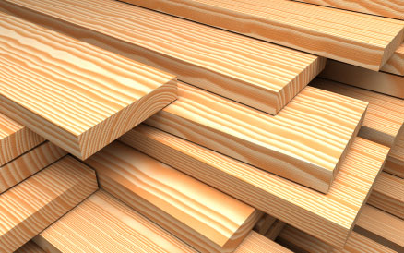

Once you have created the floor plan of your unique playhouse with a geoboard, then record your design on graph paper, and decide on the height of your playhouse. You need to find the area of the walls, floor, and ceiling then decide on the lumber you will use to construct your playhouse.

Area in Square Feet (length x width): Calculate the area of your playhouse in square feet by splitting your design into walls, floors and ceiling. Once you have found those totals, find your total play house area and justify your reasoning with words. Include the total dimensions in the chart below.

Walls Floor Ceiling Total

Lumber Prices (width x length x height):

2 x 4 x 8 = $2.97 2 x 4 x 12 = $7.77 2 x 4 x 16 = $10.97

Quantity of Lumber Pieces and Cost

|  |  |  |  |  |
| --- | --- | --- | --- | --- |
|  | # of 2x4x8 lumber | # of 2x4x8 lumber | # of 2x4x8 lumber | Cost |
| Walls |  |  |  | $ |
| Floor |  |  |  | $ |
| Ceiling |  |  |  | $ |
| Total |  |  |  | $ |

Depending on your dimensions, would you use the entire length of each piece of lumber? _____________________

If not, could you combine the pieces that you cut off of each piece of lumber? How? Explain your thinking.________

_______________________________________________________________________________________________________________________________________________________________________________________________________________________________________________________________________________________

__________________________________________________________________________________________________________________________________________________________________________________________

Would that change your quantity of lumber pieces? Justify your reasoning.__________________________________

Draw a picture of your playhouse to help you visualize:

Recalculate your lumber and cost:

|  |  |  |  |  |
| --- | --- | --- | --- | --- |
|  | # of 2x4x8 lumber | # of 2x4x8 lumber | # of 2x4x8 lumber | Cost |
| Walls |  |  |  | $ |
| Floor |  |  |  | $ |
| Ceiling |  |  |  | $ |
| Total |  |  |  | $ |

What is the difference in the quantity of lumber? ________________

Difference in cost? ______________________

5 lb (pound) box of nails = $15.97 Expect to use about 2 boxes of nails.

Lastly, choose a paint color. You may use the internet to find a specific brand and color, or simply pick your favorite crayon shade. A gallon of paint covers about 350 square feet and sells for $25.99.

What color or paint did you choose? _________________

How many gallons of paint will you need? ___________

What will the total price of paint cost? __________________

What will be the total price of the playhouse? Be sure to include cost of lumber, nails, and paint. _______________

|  |  |
| --- | --- |
| Cost of lumber | $ |
| Cost of nails | $ |
| Cost of paint | $ |
| Total cost of Playhouse | $ |

|  |  |
| --- | --- |
| **Rectangular Arrays & Area** | |
| **Enrichment Investigation #3** | |
| Common Core State Standard(s):  3. MD.5  3. MD.6  3. MD.7  3. MD.8 | Standard(s) for Mathematical Practice:  1.Make sense of problems and persevere in solving them  2.Reason abstractly and quantitatively  4. Model with mathematics  5. Use appropriate tools strategically  6. Attend to precision  7. Look for and make use of structure |
| Materials Needed:   * Blackline Masters:   + *Build & Design Your Own Dream Bedroom Instructions*   + *Dream Bedroom Design Rubric* * Rulers * Graph Paper * Pencils * Calculators * Build Your Dream Room Sheet | |
| Instructions:  *This investigation encourages students to think like Architects. Students are to design a scale diagram of an irregular shaped dream bedroom using geometric blocks. They will then trace their design onto centimeter graph paper, making a floor plan. Students then need to calculate each room’s perimeter and area then find the total area and perimeter of their floor plan.*   1. Distribute *Build & Design Your Own Dream Room & Bedroom Floor Plan Example Sheet* to students. 2. Students will work independently. 3. Have students set goals/time frame for completing work. Check in on progress. 4. Give students time to share. 5. Evaluate | |
| Sources: | |

Build & Design Your Own Dream Bedroom

Assignment with Guidelines:

1. With the assistance of geometric shapes, layout an irregular shaped floor plan for your dream bedroom.
2. Trace your irregular shaped bedroom floor plan on centimeter graph paper.
3. Predict and then determine the perimeter of your bedroom.
4. Predict and then determine the area of your bedroom.
5. Optional: Research blueprint symbols to use.
6. Include a scale on your blueprint. Example: 1 cm. = 1 ft.
7. This bedroom must include labeled door(s), window(s) and closet(s).
8. Your bedroom may have an attached irregular shaped bathroom and bathroom closet.

Name of Architect/Interior Designer: ______________________________________________________

PERIMETER

Perimeter of Bedroom:

Prediction ___________________________­_

Find the actual perimeter of you irregular shaped bedroom. Show your work by explaining your thinking using pictures, numbers, and words:

Actual Perimeter ___________________________________

Perimeter of Bedroom Closet:

Prediction ___________________________­_

Find the actual perimeter of your irregular shaped bedroom closet. Show your work by explaining your thinking using pictures, numbers and words:

Actual Perimeter ___________________________________

Perimeter of Bathroom:

Prediction ___________________________­_

Find the actual perimeter of your irregular shaped bathroom. Show your work by explaining your thinking using pictures, numbers, and words:

Actual Perimeter ___________________________________

Perimeter of Bathroom Closet:

Prediction ___________________________­_

Find the actual perimeter of your irregular shaped bathroom closet. Show your work by explaining your thinking using pictures, numbers, and words:

Actual Perimeter ___________________________________

AREA

Area of Bedroom:

Prediction ___________________________­_

Find the actual area of your irregular shaped bedroom. Show your work by explaining your thinking using pictures, numbers and, words:

Actual Perimeter ___________________________________

Area of Bedroom Closet:

Prediction ___________________________­_

Find the actual area of your irregular shaped bedroom closet. Show your work by explaining your thinking using pictures, numbers, and words:

Actual Perimeter ___________________________________

Area of Bathroom:

Prediction ___________________________­_

Find the actual area of your irregular shaped bathroom. Show your work by explaining your thinking using pictures, numbers, and words:

Actual Perimeter ___________________________________

Area of Bathroom Closet:

Prediction ___________________________­_

Find the actual area of your irregular shaped bathroom Closet. Show your work by explaining your thinking using pictures, numbers, and words:

Actual Perimeter ___________________________________

Total Perimeter of Irregular Dream Bedroom Total Area of Irregular Dream Bedroom

­­

Top of Form

|  |  |  |  |  |  |
| --- | --- | --- | --- | --- | --- |
| **Dream Bedroom Design** | | | | | |
|  | 1 | 2 | 3 | 4 |  |
| **Floor Plan** | Floor plan is not complete. | Floor plan is complete but there is some inaccurate information. The floor plan drawing is messy, ruler was not used. The scale may be incorrect. Area & perimeter configurations may be off. | Floor plan is complete. There are few if any mistakes. A ruler was clearly used showing neat, straight lines. Area and perimeter are labeled with dimensions. Work is shown with words, pictures or numbers. | Floor plan is complete with no mistakes. Lines are neat and symbols are used correctly. Attention to detail is evident. Area and perimeter of room are labeled with dimensions. Work is shown with words, pictures and numbers. |  |
|  |  |  |  |  |  |
|  |  |  |  |  |  |
|  |  |  |  |  |  |
| **Work Habits** | Student barely works on project and is often off task. | Student works on project but is often distracted and off task. | Student works hard on project and is seldom off task | Student is passionate about project and uses time very wisely. |  |
| **Calculations** | There are no calculations for area and perimeter of bedroom, bedroom closet, bathroom and bathroom closet. | Most of the calculations for area and perimeter of bedroom, bedroom closet, bathroom and bathroom closet is correct. | All the calculations are correct without work shown. | All calculations are correct with work shown. |  |
| **Creativity** | The floor plan does not include irregular shapes. | The floor plan includes some irregular shapes | The floor plan is complete with the bedroom, bedroom closet, bathroom and bathroom closet all being irregular shapes. | The floor plan is complete with the bedroom, bedroom closet, bathroom and bathroom closet all being irregular shapes. Student went above and beyond by drawing in large furniture; bed, dresser, nightstand…etc. |  |

Bottom of Form

|  |  |
| --- | --- |
| **Rectangular Arrays & Area** | |
| **Enrichment Investigation #4** | |
| Common Core State Standard(s):  3. MD.5  3. MD.6  3. MD.7  3. MD.8 | Standard(s) for Mathematical Practice:  1.Make sense of problems and persevere in solving them  2.Reason abstractly and quantitatively  3. Construct viable arguments and critique the reasoning of others  4. Model with mathematics  6. Attend to precision |
| Materials Needed:   * Blackline Masters:   + *Puppy Pen* * Pencil * Notebook Paper * Graph Paper * Ruler * Computer and/or Fencing Catalogs | |
| Instructions:  *Students are to persuade their parents into letting them get a puppy. They first need to design a puppy pen that has an area of 40 square feet with the smallest perimeter. Next, they need to shop for fencing and calculate the total cost (trying to spend the least amount of money). Students must attach a picture of their chosen fence and include the dimensions and cost. They will then write a persuasive letter to their parents, including: R*easons why they deserve a puppy; how they designed a space with an area of 40 square feet with the smallest perimeter and why; which fencing they choose and why (include the cost configurations, dimensions, and picture); and their puppy pen design drawn on graph paper with a conclusion.   1. Distribute *Puppy Pen Sheet* to students. 2. Tell students where shared fencing catalogs will be located. 3. Students will work independently. 4. Have students set goals/time frame for completing work. Check in on progress. 5. Give students time to share. 6. Evaluate | |
| Sources: | |

Puppy Pen

You recently saw an ad in the newspaper that stated “free puppies” and you have always wanted one. After researching, you’ve learned that 40 square feet would be the perfect size area for a puppy’s pen. You keep begging your parents, but they tell you that it is too expensive to fence in the backyard. Your task is to design an area that is 40 square feet with the least amount of fencing. You’re hoping that you can calculate the smallest perimeter of fencing so the cost isn’t too high. When you have designed an area that is 40 square feet with the smallest perimeter for fencing, research what fence you can purchase for the least amount of money. Include a picture of the fence with the dimensions and cost. Research at least 3 different hardware stores and/or fencing companies to compare prices and to make sure your have the best quote. When you have the cheapest quote, write a persuasive letter to your parents informing them of the information that you found and your reasons for wanting a puppy.

Your persuasive letter should include:

* Reasons why you deserve a puppy.
* How you designed a space with an area of 40 square feet with the smallest perimeter and why.
* Which fencing you choose and why (include the cost configurations, dimensions, and picture).
* Your puppy pen design drawn on graph paper.
* Conclusion

Sample Fencing Pictures & Cost:

Pressure Treated Pine Traditional PB Rail 3-Rail Picket Top Aluminum

[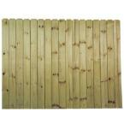](http://www.homedepot.com/Building-Materials-Fencing/h_d1/N-5yc1vZbb05/R-100063484/h_d2/ProductDisplay?catalogId=10053&langId=-1&storeId=10051) [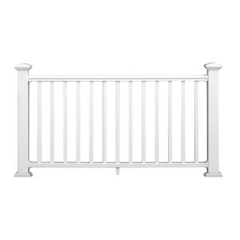](javascript:openFeatureFlex('http://cache.vendaria.com/vpop/VpopX.html?bg=D6D7A5&nm=BZOpener&err=0&title=Demo&pf=t&fr=t&iid=jmIkUFkQcffdQVeUajbacdkfffaijkQgQji&purl=sys_homedepot_uid_202084782&uid=202084782&cf=3000','','768','705',true,false,false,false,false,false);) [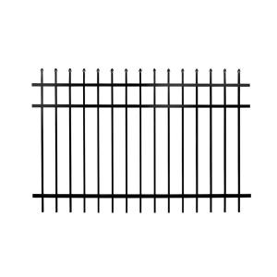](javascript:openFeatureFlex('http://cache.vendaria.com/vpop/VpopX.html?bg=D6D7A5&nm=BZOpener&err=0&title=Demo&pf=t&fr=t&iid=jmIkUFkQcffdQVeUajbacdkfffaijkQgQji&purl=sys_homedepot_uid_203333278&uid=203333278&cf=3000','','768','705',true,false,false,false,false,false);)

6 ft. x 8 ft. 6 ft. x 36 in. 4 ft. x 6 ft.

$44.97/ piece $49.97/piece $54.99/piece

Use the sample fencing above or look up your own using the following links:

Home Depot: [www.homedepot.com](http://www.homedepot.com)

Lowes: [www.lowes.com](http://www.lowes.com)

Build Direct: [www.builddirect.com](http://www.builddirect.com)

Aluminum Fences Direct: [www.aluminumfencesdirect.net](http://www.aluminumfencesdirect.net)

|  |  |  |  |  |  |
| --- | --- | --- | --- | --- | --- |
| Company | | Type of Fencing | Dimensions | | Total Cost |
|  | |  |  | |  |
|  | |  |  | |  |
|  | |  |  | |  |
| **Rectangular Arrays & Area** | | | | |
| **Enrichment Investigation #5** | | | | |
| Common Core State Standard(s):  3. MD.5  3. MD.6  3. MD.8 | | | Standard(s) for Mathematical Practice:  1.Make sense of problems and persevere in solving them.  2.Reason abstractly and quantitatively.  4. Model with mathematics.  5. Use appropriate tools strategically.  6. Attend to precision. | |
| Materials Needed:   * Blackline Masters:   + *North Carolina’s Perimeter*   + *South Carolina Map* * Paper * Pencil * Centimeter graph paper * Computer to print a physical map of South Carolina | | | | |
| Instructions:  *This is a challenge where students will use their map skills to trace and estimate North Carolina’s and South Carolina’s areas and perimeters. They will compare the 2 states’ physical maps. Work should be done independently by the students.*   1. Distribute *North Carolina’s Area and Perimeter Sheet* to students. 2. Explain that the North Carolina map shown is a physical map. 3. Point out the scale below the physical map. They need to use this to estimate North Carolina’s area and perimeter. 4. Students will need to use a computer to locate a physical map of South Carolina & print it out. Pass out South Carolina’s physical map if a computer is not available. 5. They will draw and fill out a Venn Diagram on a separate sheet of paper, comparing North Carolina and South Carolina. 6. Students will then choose a third state, research and print a physical map then estimate the area and perimeter of this state. They need to make a Triple Venn Diagram comparing North Carolina, South Carolina, and the third state. 7. If students don’t have access to a computer, you can give them the third state attached (Virginia). You will not need to print the 2 Virginia sheets if students will find their own on the computer. 8. Evaluate | | | | |

North Carolina’s Area and Perimeter

1. Using the scale below, estimate the area and perimeter of North Carolina. Cut and trace the attached North Carolina physical map onto centimeter graph paper. Remember, 50km = 1 cm. Make sure you show your work.

[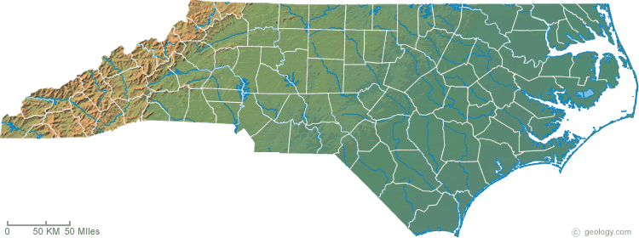](http://geology.com/topographic-physical-map/north-carolina.shtml)

### North Carolina Physical Map

Explain your thinking at least 2 different ways (using pictures, numbers, symbols and/or words). Use a separate sheet of paper if you need more space.

Area of North Carolina: _____________________________________________________

Perimeter of North Carolina: ________________________________________________

1. Research and print a physical map of South Carolina. Estimate the area and perimeter the same way. Draw a Venn Diagram on the back of this paper and compare North Carolina’s and South Carolina’s physical maps.

South Carolina

[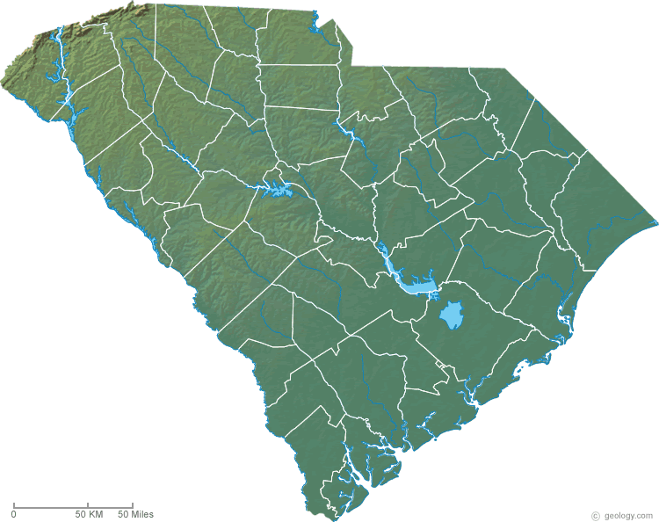](http://geology.com/topographic-physical-map/south-carolina.shtml)

### South Carolina Physical Map

Explain your thinking at least 2 different ways (using pictures, numbers, symbols and/or words). Use a separate sheet of paper if you need more space.

Area of South Carolina: _____________________________________________________

Perimeter of South Carolina: ________________________________________________

**If students don’t have computer access to research and print a third state of their choice, have then use this:**

Virginia

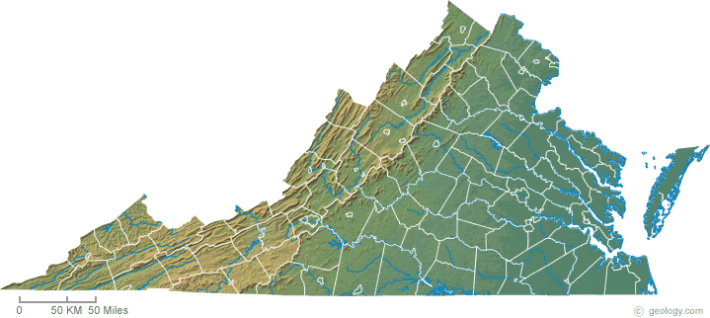

### Virginia Physical Map

Explain your thinking at least 2 different ways (using pictures, numbers, symbols and/or words). Use a separate sheet of paper if you need more space

Area of Virginia: _____________________________________________________________

Perimeter of Virginia: _______________________________________________________

Physical Maps to cut and trace:

North Carolina

[](http://geology.com/topographic-physical-map/north-carolina.shtml)

South Carolina

[](http://geology.com/topographic-physical-map/south-carolina.shtml)

Virginia

